Coppermill Heights Equans
Waterside Way 109 – 110 Vickers Court
London N17 9FH Waterside Way
London N17 9FT

2nd October 2026
Dear Residents,
RE: Coppermill Heights – Progress Update Week Commencing 5th October 2026
We are writing to provide you with our latest weekly update regarding the ongoing works at Coppermill Heights.
Block 1 – Cladding Works
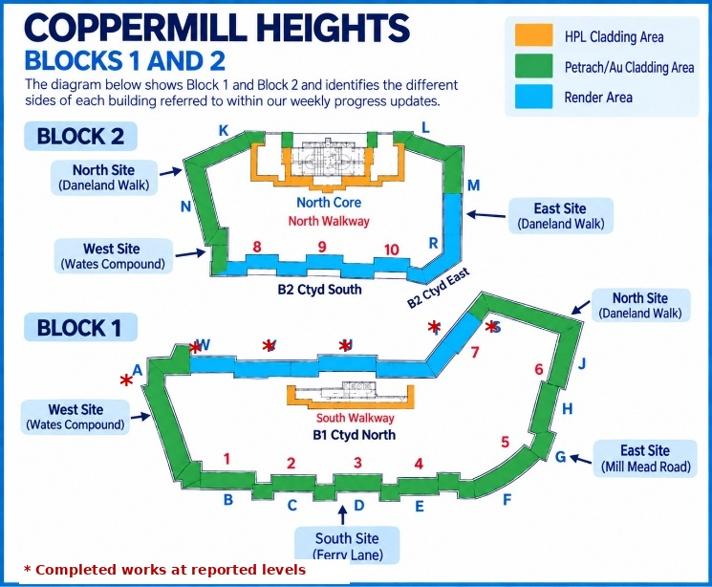
Good progress has been made to Block 1 during the past week. Works have now been completed to Level 5 on side U, V and W, together with side S and T at Levels 4 and 5. Sign-off has been completed and the scaffolding to these sides has been lowered.

Throughout the coming week, works will continue with the replacement of defective panels at the lower levels of Block 1, with scaffolding removed from completed and signed-off areas wherever possible.
Block 2 – Cladding Works
Installation works have now commenced to the south side of Block 2 at Level 5, as planned. Works are progressing and scaffolding is being removed from completed and signed-off areas wherever possible.
During the coming week, panel replacement works will continue to the south and east side of Block 2.
Scaffolding – Blocks 1 and 2
The removal of scaffolding remains on course and is continuing across both blocks. Scaffolding is being lowered and removed wherever panel replacement works have been completed and signed off.
Programme Update
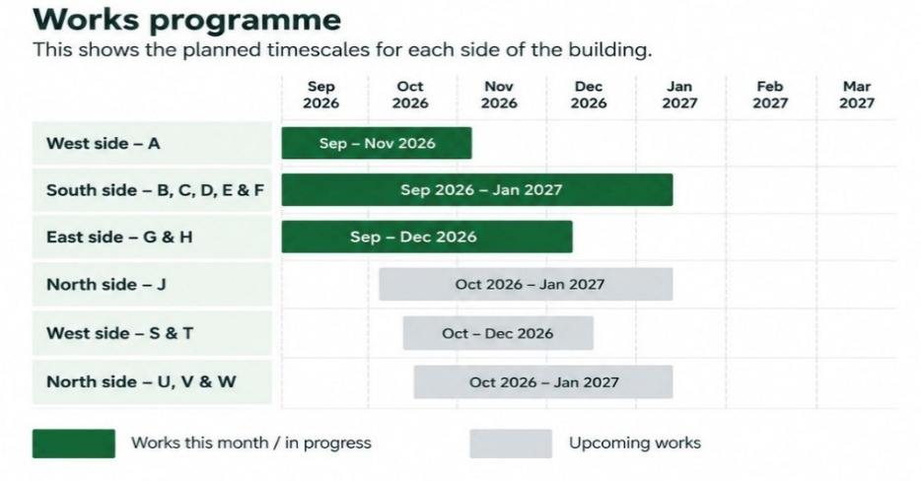
The works are currently progressing in line with the programme, with no significant delays or issues to report at this time.

We will continue to monitor progress and advise residents should there be any changes that may affect the programme.

Looking Ahead
During the coming week, works will continue to focus on replacing defective panels to the lower levels of Block 1, continuing panel replacement to the south and east elevations of Block 2, and lowering or removing scaffolding wherever works have been completed and signed off.
There are currently no significant delays or changes to the programme to report. We are currently working towards having the scaffolding removed by the end of December. This is dependent on the continued progress of the works and no unforeseen circumstances to cause delay.
We will continue to provide weekly updates as the works progress and advise residents of any changes. Thank you for your continued patience, cooperation and understanding.

Yours sincerely,
EQUANS Regeneration Ltd.
Polly Moona - Senior Resident Liaison Officer
Tel: 07816 205060 - Email Address: Polly.moona@equans.com

Armani Rose – Resident Liaison Officer (Onsite)
Tel: 07483993895 - Email Address: Armani.Rose@equans.com
You can also direct enquiries to the Newlon Special Projects Team at: SpecialProjects@newlon.org.uk

