Coppermill Heights Equans.
Waterside Way 109 – 110 Vickers Court
London N17 9FH Waterside Way
London N17 9FT

25th September 2026

Dear Residents,
RE: Coppermill Heights – Progress Update Week Commencing 28th September 2026
We are writing to provide you with our latest weekly update regarding the ongoing works at Coppermill Heights.
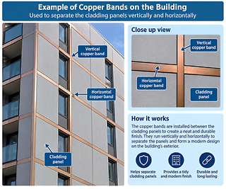
Block 1 – Cladding Works
As part of the ongoing cladding programme, the copper bands are being replaced alongside the external works to the building. Replacement of the copper bands to Block 1 is progressing in line with the current programme.
Block 2 – Cladding Materials
The cladding materials for Block 2 have arrived on site as planned and the required quality assurance checks have been carried out.
Installation of these on the east and south sides of Block 2 is due to commence during week beginning 28th September on the east and south sides of Block 2.
Water Testing
The water leak investigation report has now been received and has successfully identified the source of the leak, which has now been repaired. As the project progresses, the scaffolding used for this will be removed level by level over the coming weeks.
Balcony Works
Decking works to the second outstanding balcony are currently in progress and are planned to be completed by Friday 2nd October.
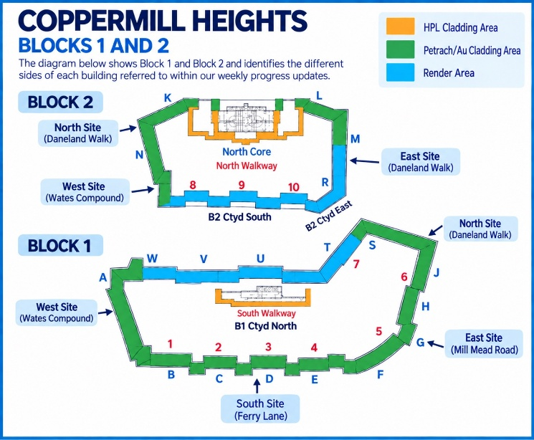
Scaffolding – Blocks 1 and 2
Works to sides A, S and T at Level 5 have now been completed and signed off. The scaffolding to these completed areas is currently being taken down.
The scaffold towers to both blocks are being taken down as planned, together with scaffolding to the areas where the copper bands have been replaced.
Looking Ahead
During the coming week, works will continue to focus on cladding installation to Block 2, removal of scaffolding from completed areas and completion of the remaining balcony works.
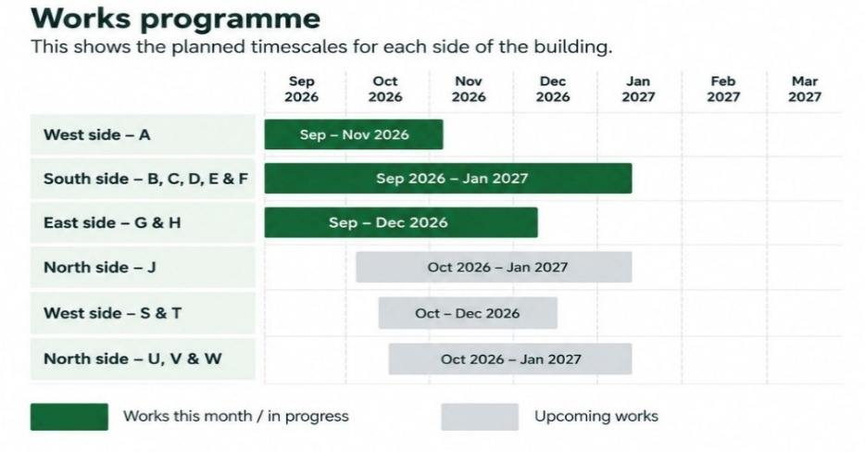
The diagrams below outline the cladding areas and the anticipated programme of works. These may be subject to change, depending on weather and site conditions and we will keep you updated.

There are currently no significant delays or changes to the programme to report. We are currently working towards having the scaffolding removed by the end of December. This is dependent on the continued progress of the works and no unforeseen circumstances to cause delay.
We will continue to provide weekly updates as the works progress and advise residents of any changes.

Thank you for your continued patience, cooperation and understanding.

Yours sincerely,
EQUANS Regeneration Ltd.

Polly Moona - Senior Resident Liaison Officer
Tel: 07816 205060 - Email Address: Polly.moona@equans.com

Armani Rose – Resident Liaison Officer (Onsite)
Tel: 07483993895 - Email Address: Armani.Rose@equans.com

You can also direct enquiries to the Newlon Special Projects Team at: SpecialProjects@newlon.org.uk

