Coppermill Heights Equans Regeneration Ltd.
Waterside Way 109 – 110, Vickers Court
London N17 9FH Waterside Way
London N17 9FT
18th September 2026
Dear Residents,
RE: Coppermill Heights – Progress Update Week Commencing 21st September 2026
We are writing to provide you with our latest weekly update regarding the ongoing works at Coppermill Heights.
Block 1 – Cladding Works
We are pleased to confirm that reinstatement of the cladding to Block 1 is now in progress.
The works are progressing in line with the current programme and at present, no delays have been reported.
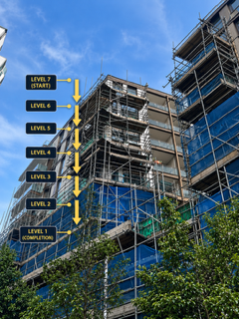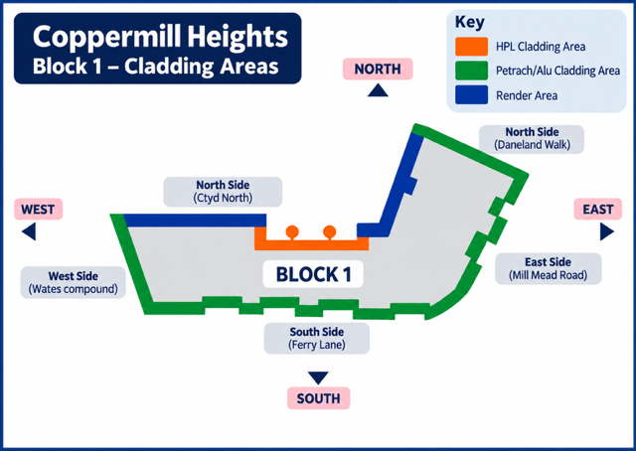
Block 2 – Cladding Materials
The cladding materials for Block 2 are currently expected to be delivered by the end of this week.
Once the materials have arrived and the necessary quality checks have been completed, we will provide a further update on when the cladding works to Block 2 will commence.

Water Testing
We are still awaiting the formal report from the water testing that took place on 3rd September.
Initial feedback received following the testing indicates that the leak does not appear to be associated with the works carried out by Equans; however, this remains subject to confirmation within the formal report.
Once the report has been received and reviewed by the relevant teams, we will provide a further update and advise residents of any additional works that may be required.
Scaffolding – Blocks 1 and 2
Removal of the scaffolding that is no longer required has now commenced.
Block 1, the top section has been removed and the scaffolding has now been reduced to Level 6.
Block 2, the top section has also been removed and the scaffolding has now been reduced to Level 5.
Where cladding was temporarily removed to allow the water testing to take place, this will be replaced as the works progress.
The remaining scaffolding will continue to be removed gradually as works are completed.
The roadworks taking place next to part of our scaffolding are progressing slowly, which is affecting how quickly it can safely be removed.
Balcony Works
Works to the one outstanding balcony are currently underway and are expected to be completed by the end of next week.
Looking Ahead
During the coming week, works will continue to focus on cladding, scaffolding removal and the remaining balcony works.
The diagrams below outline the cladding area and the anticipated programme of works, these are subject to change pending the weather.

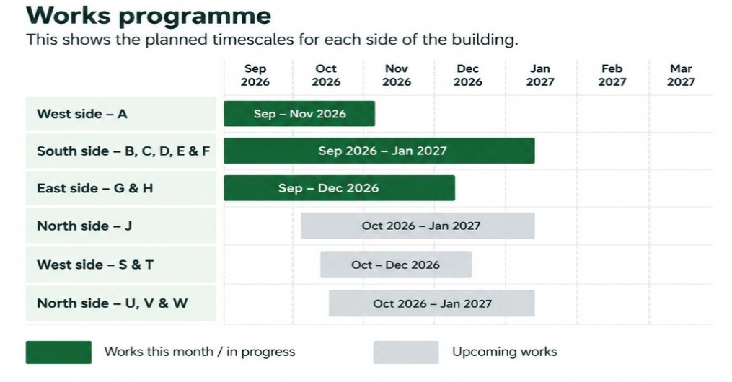
There are currently no significant delays or changes to the programme to report.
We will continue to provide weekly updates as the works progress and advise residents of any significant changes.
Thank you for your continued patience, cooperation and understanding.
Yours sincerely,
EQUANS Regeneration Ltd.
Polly Moona - Senior Resident Liaison Officer
Tel: 07816 205060
Email Address: Polly.moona@equans.com
Armani Rose – Resident Liaison Officer (Onsite)
Tel: 07483993895
Email Address: Armani.Rose@equans.com

You can also direct enquiries to the Newlon Special Projects Team at: SpecialProjects@newlon.org.uk

