Coppermill Heights Equans Regeneration Ltd.
Waterside Way 109 – 110, Vickers Court
London N17 9FH Waterside Way
London N17 9FT

11th September 2026

Dear Residents,
RE: Coppermill Heights – Progress Update Week Commencing 14th September
We are writing to provide you with our latest update regarding the ongoing works at Coppermill Heights. We apologise for the delay in getting this to you.
Cladding Materials and Works
We are pleased to confirm that the cladding materials for Block 1 have now arrived on site. These materials are currently subject to the necessary quality checks before installation commences.
Subject to the satisfactory completion of these checks, we are planning to recommence the cladding works week commencing Monday 14th September 2026.
The works are currently programmed to progress from the top to bottom of the building from west going to south, east and finally to north elevations.
The works are anticipated to take approximately 16 weeks for Block 1, but we are aiming to complete and take the scaffold down before Christmas break depending to weather. We will confirm when Block 2 will commence, after receiving the materials for this, which is anticipated by the end of next week. This is expected to take 8 weeks to complete.
Please see the diagram below of Coppermill Heights, which provides a visual representation of the layout and key areas.

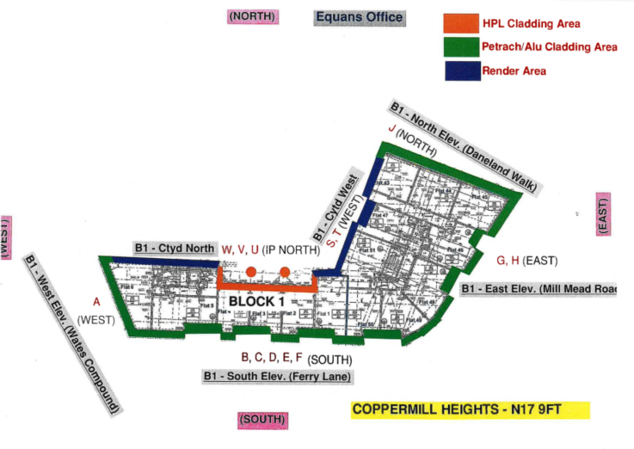

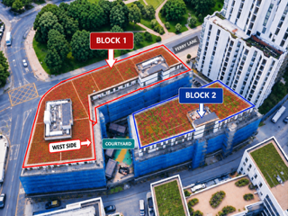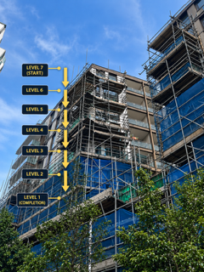

Water Testing
Water testing was carried out last week as part of the ongoing investigation and remedial works to the building.
We are currently awaiting the formal report and findings from the testing. Once the report has been received and reviewed by the relevant teams, any necessary follow-on actions will be identified and incorporated into the programme of works.
Scaffolding Towers – Blocks 1 and 2
The scaffolding towers to Block 1, Ferry Lane and Block 2, have been used to facilitate the water testing and associated external works.
Following completion of the testing, we are awaiting the report before confirming whether any further works are required in these areas.
Where cladding has been temporarily removed to facilitate the testing, this will be reinstated as the works progress, following which the associated scaffolding towers will be removed when they are no longer required.
Balcony Works
Works are continuing to the balconies where access and the programme allow.
These works form part of the remaining works across the project, and our site team will continue progressing balcony works alongside the cladding and other external works.
We appreciate that residents are keen to see the remaining works progress. The arrival of the cladding materials and planned recommencement of the cladding installation represents an important next stage of the programme.
We will continue to provide weekly updates as the works progress. Thank you for your continued patience, cooperation and understanding.
Yours sincerely,
EQUANS Regeneration Ltd.
Polly Moona - Senior Resident Liaison Officer
Tel: 07816 205060
Email Address: Polly.moona@equans.com
Armani Rose – Resident Liaison Officer (Onsite)
Tel: 07483993895
Email Address: Armani.Rose@equans.com

You can also direct enquiries to the Newlon Special Projects Team at: SpecialProjects@newlon.org.uk

